**Practical No: 2**

**How to Add Session host Manually to Host pool**

**Agenda:**

Section 3: Implement Azure Virtual Desktop Host pool

1. Step by Step Implementation:
2. Create resource group
3. Create Virtual Network (internal)
4. Create a host pool
5. Create Azure virtual desktop (create a session host)
6. Assign an AD user
7. Add Role Assignment and Add members.
8. Add virtual desktop workspaces
9. Configure Virtual Desktop host pool
10. Log in to the Azure Virtual Desktop (Session Desktop).
11. To Add Session host manually to Host pool
12. **Step by Step Implementation to Add Session host Manually to Host pool:**
13. Creating a New Azure Resource Group:

* In the Azure portal, select 'Resource groups' from the left-hand menu, then select '+ Add resource group'.
* In the 'Create resource group' blade, enter a name for your resource group and select the 'Subscription', 'Resource group location', and 'Pricing tier' fields. Then, select 'Create'.

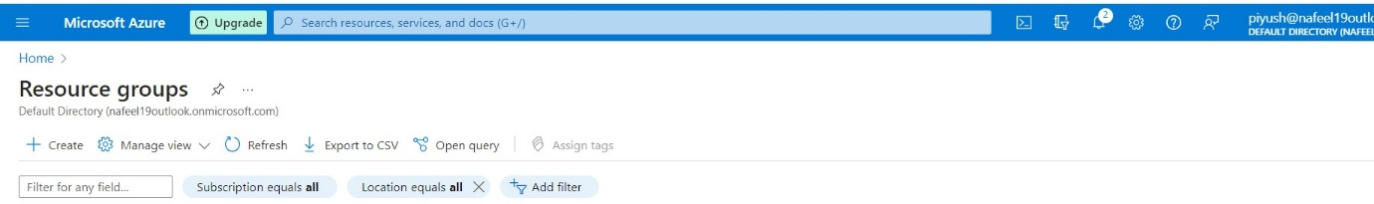

* 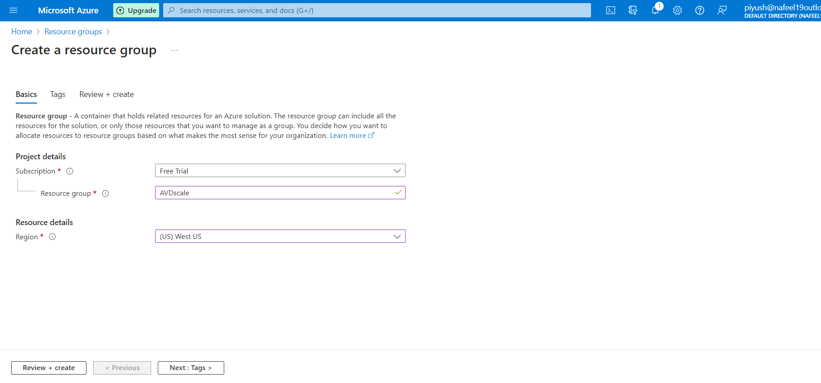In the 'Create resource group' blade, enter a name for your resource group and select the 'Subscription', 'Resource group location', and 'Pricing tier' fields. Then, select 'Create'.

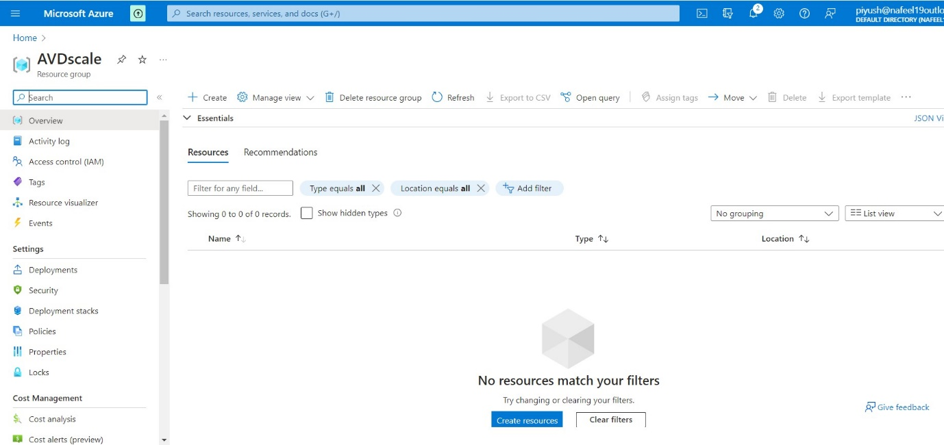

1. ***Create a virtual network:***

We need to create a virtual network for the machines we are going to use later on. To do this, perform the following steps:

* Open Azure Portal as an Administrator.
* Search for Virtual Networks.
* 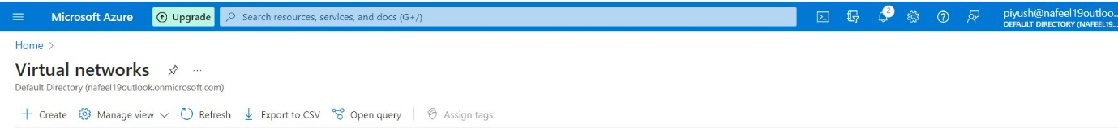Click on Create.
* Select your subscription type and add the existing created AVDscale resource group that will have access to the network.
* 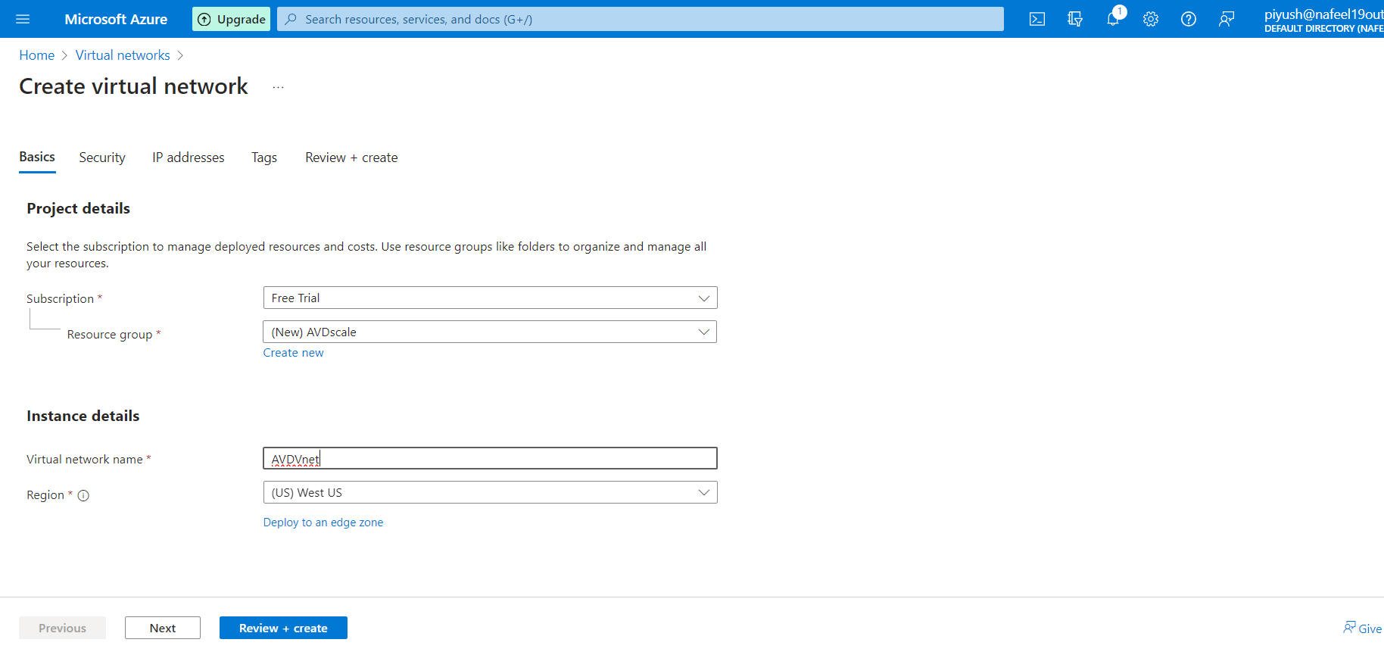Give a name to the virtual network and select the region.
* 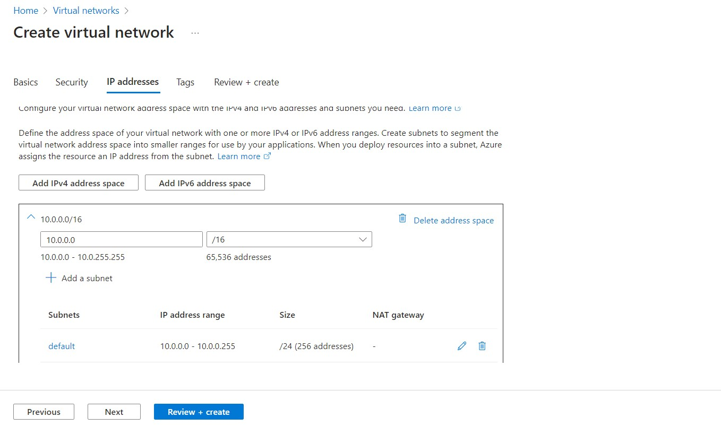In the IP Addresses tab, leave everything as default.
* 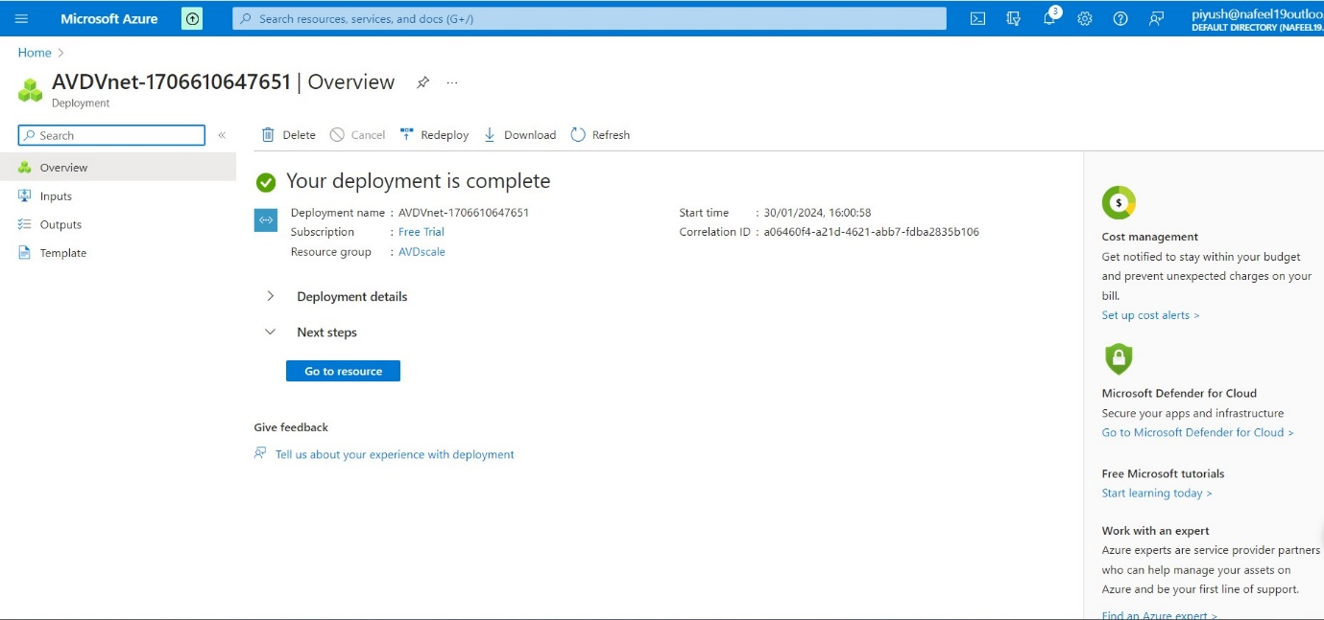Click to create virtual network

1. ***Create a host pool:***

After the virtual network is configured, we need to create a host pool for the virtual machines. To do this, perform the following steps:

* + In Azure Portal, search for Azure Virtual Desktop.
* 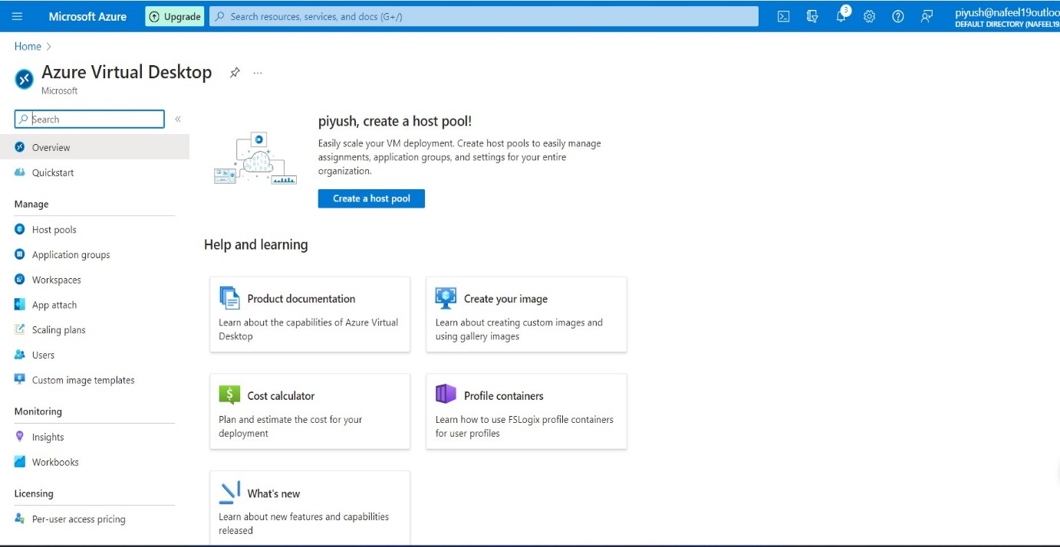Click on Create a host pool.
  + Select your subscription and choose the existing created resource group - AVDscale you previously added for the virtual network.
  + Add a host pool name and location West US, keep same location for all the process in AVD.
  + Under the host pool type, select pooled.
  + Under the Load balancing, select Breadth-first
  + Max session limit as per requirement.
  + 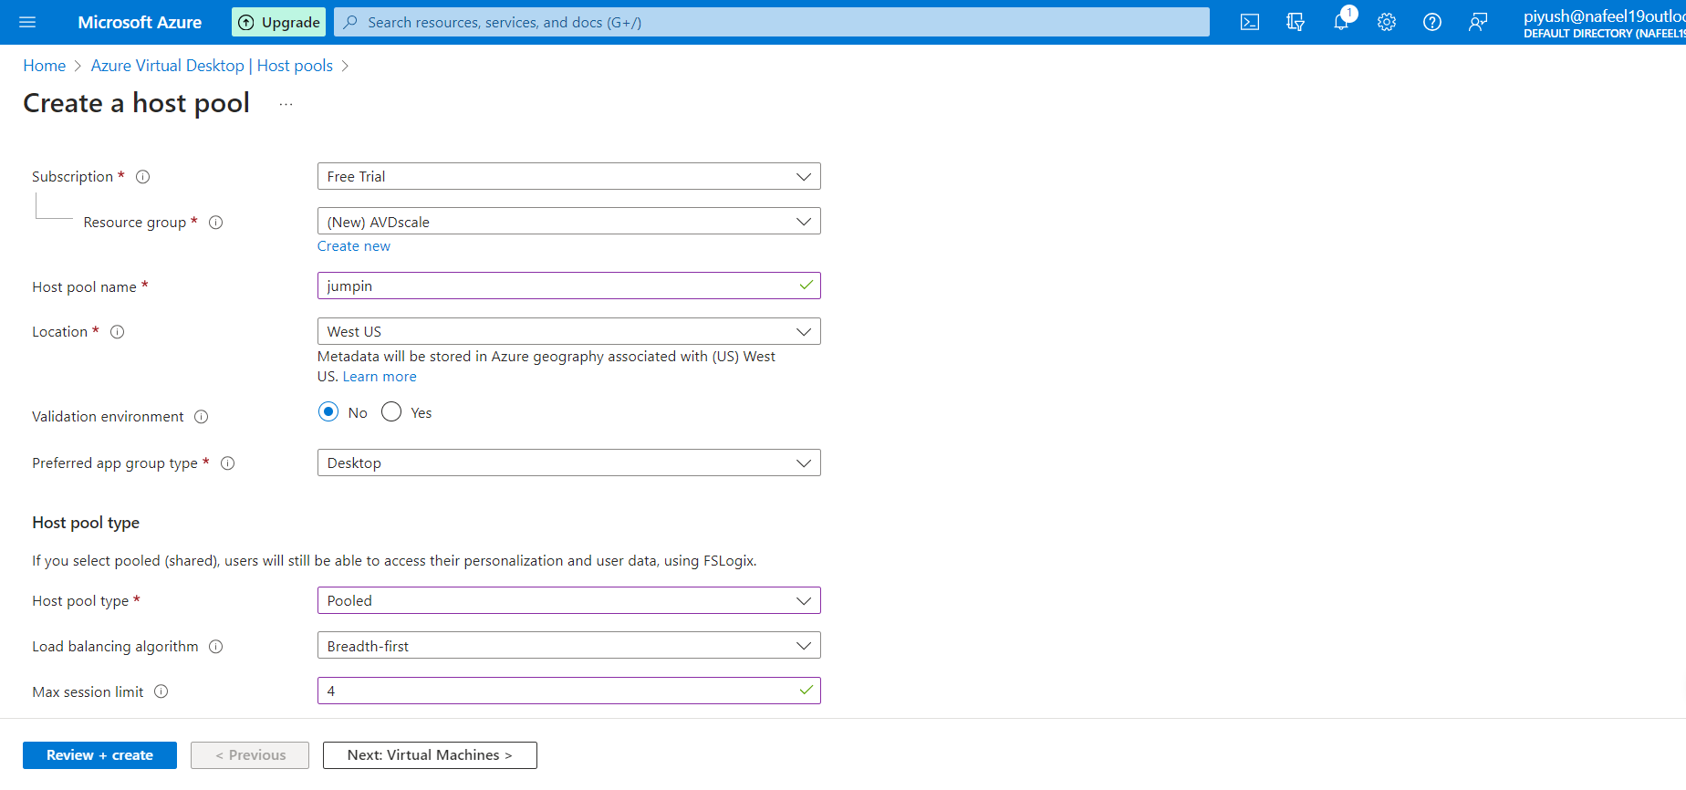Click Next.

1. ***Create Azure virtual desktop (create a session host):***
   * In the Virtual Machines tab, select Yes to add a virtual machine.
   * Add existing created Resource group AVDscale.
   * 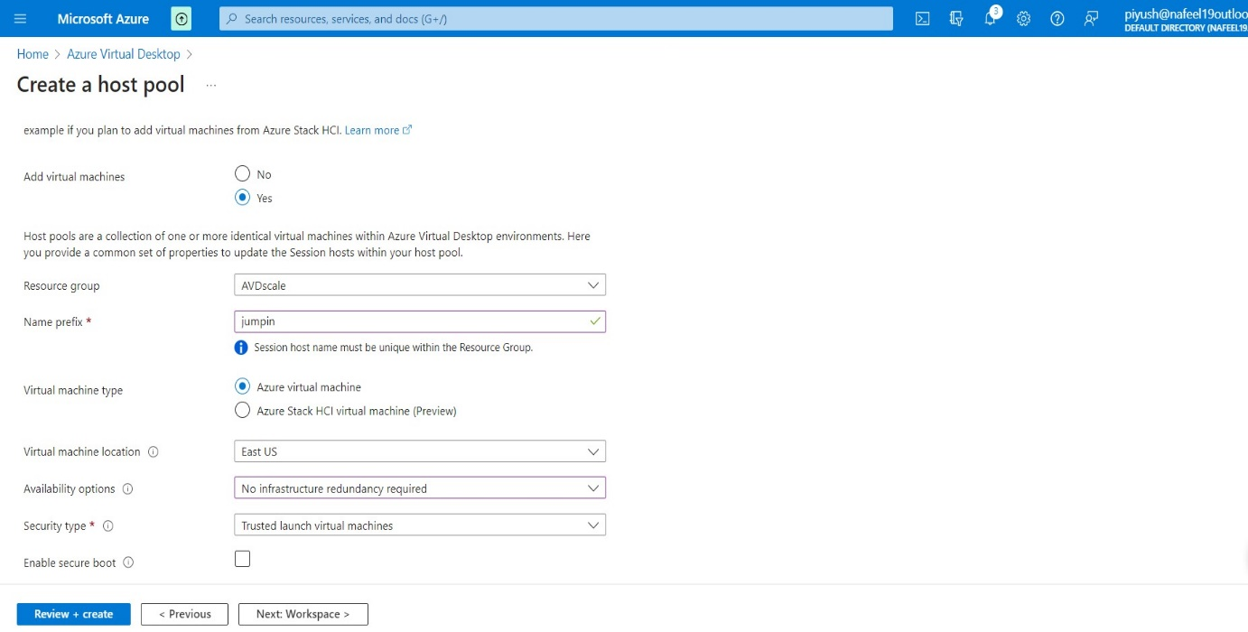Add a prefix name and location West US, keep same location for all the process in AVD.
   * 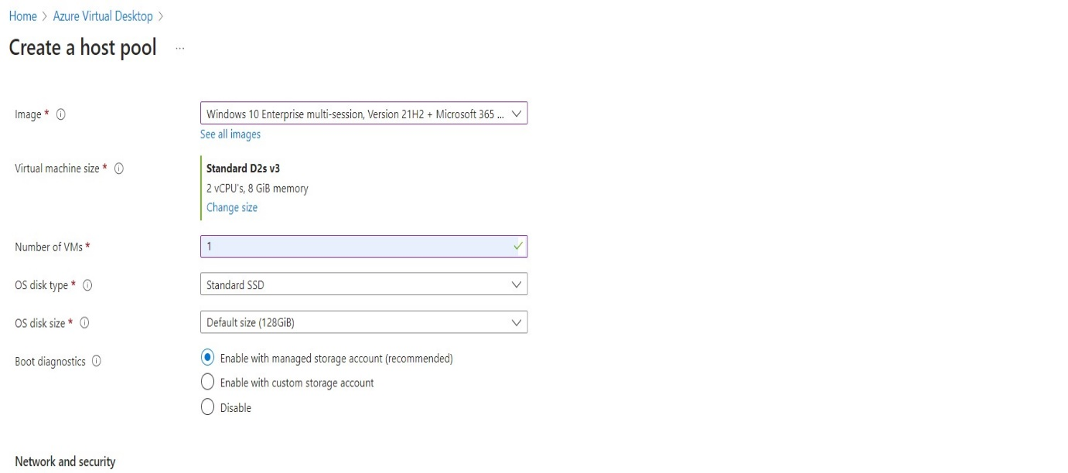You can add as many machines as you want in this step. We only added one and left everything else to standard.

* Under the Network and security, make sure to select the previously created Virtual Network. No other network configurations are necessary.

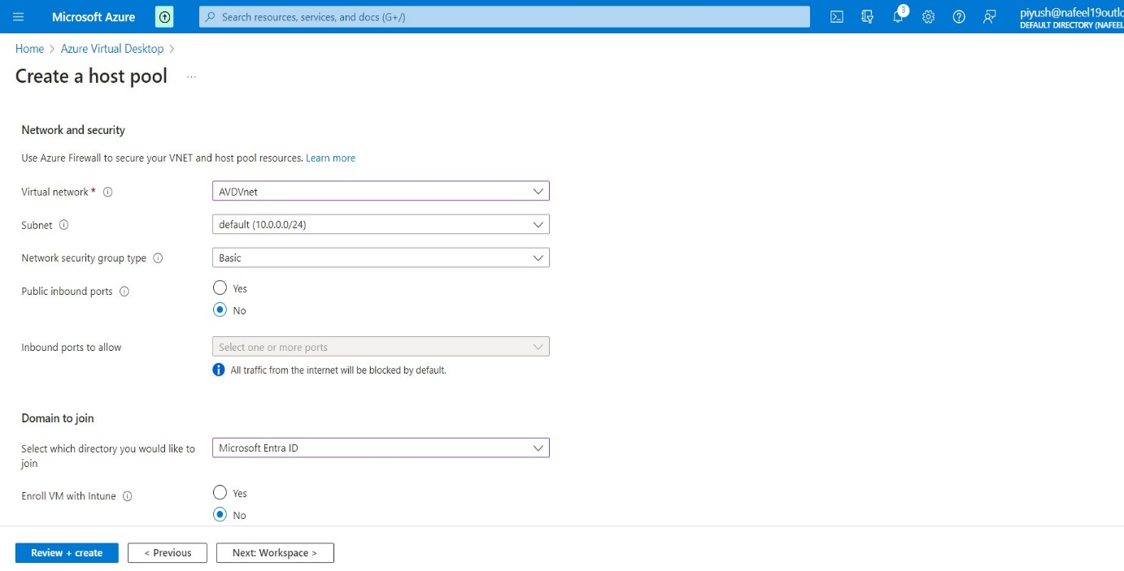

* Under Domain to join.
* In our case, we don’t have a separate AD site, so we chose to join with the Azure Active Directory. We also went with the option to not enrol the VM with Intune.
* As a last step in this tab, put user name and Password administrator account so you can access the VM.
* 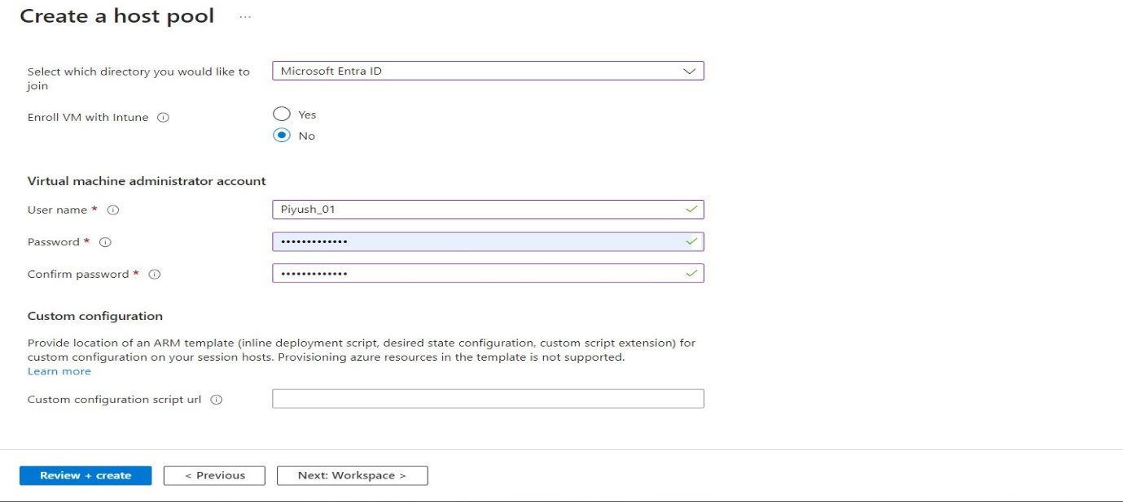Click Next.
* 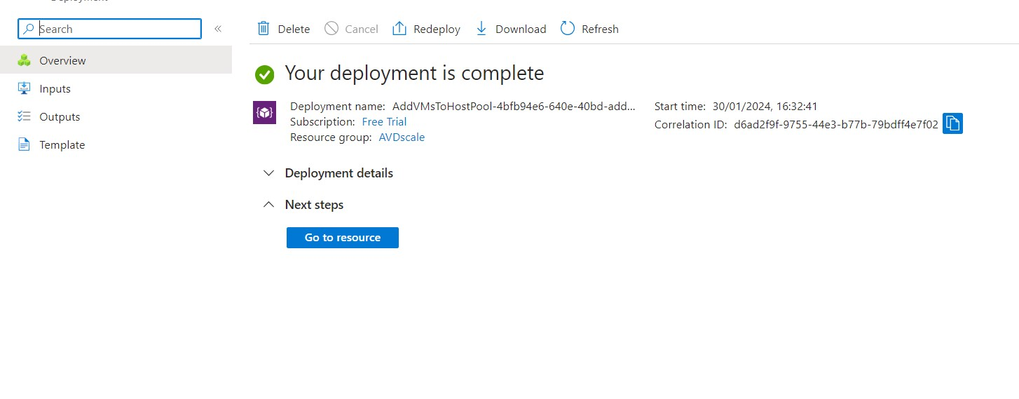Click to Create AVD Host pool.
* 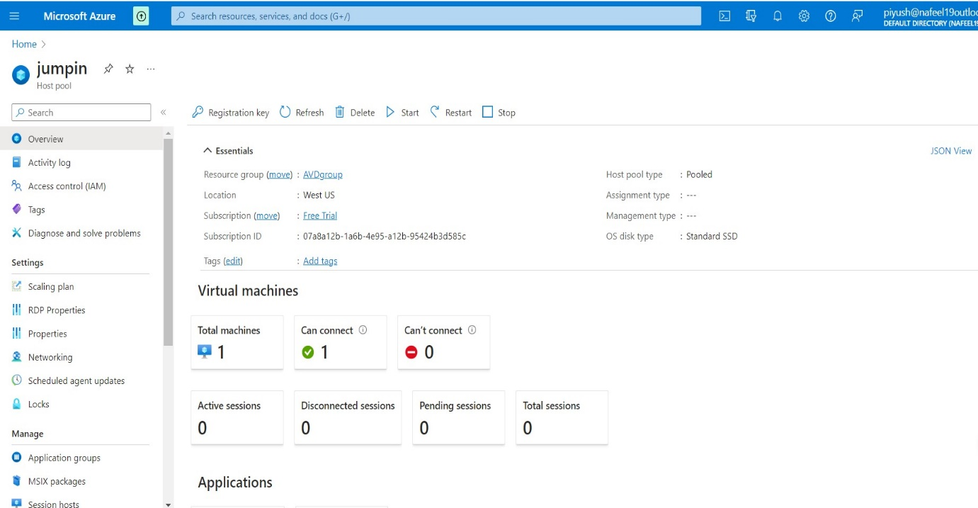Host pool is ready.

1. ***Assign an AD user:***

* 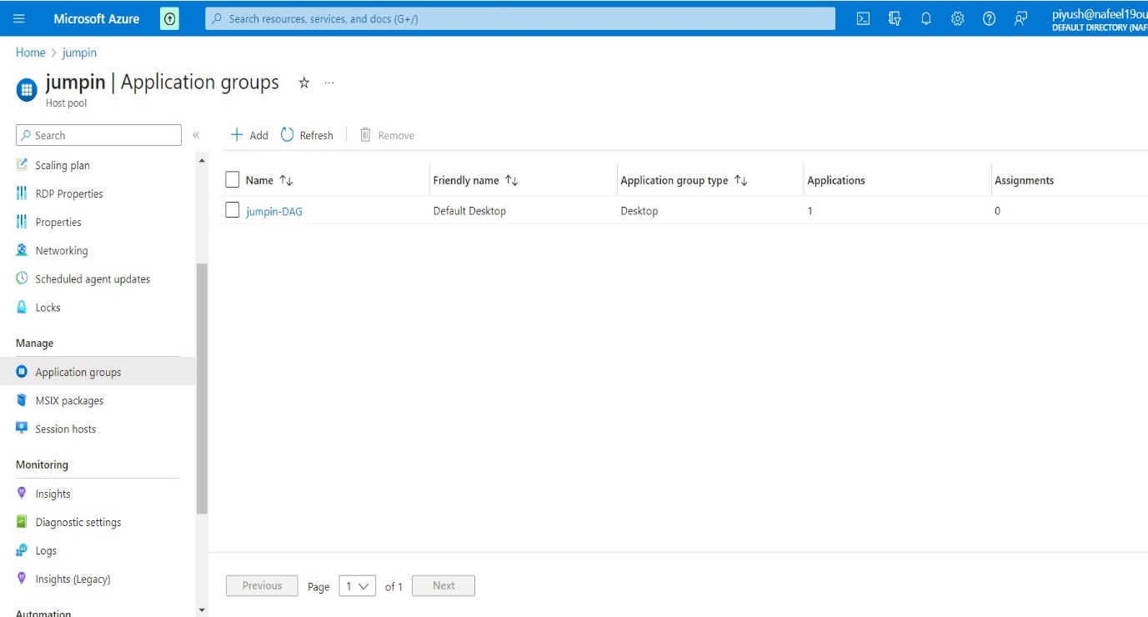In Manage → Application groups

**↑**

**Click on jumpin-DAG**

**←**

* In Application groups →Click on jumpin-DAG →In Manage →Assignments

**↑**

**Click to Add**

**←**

* 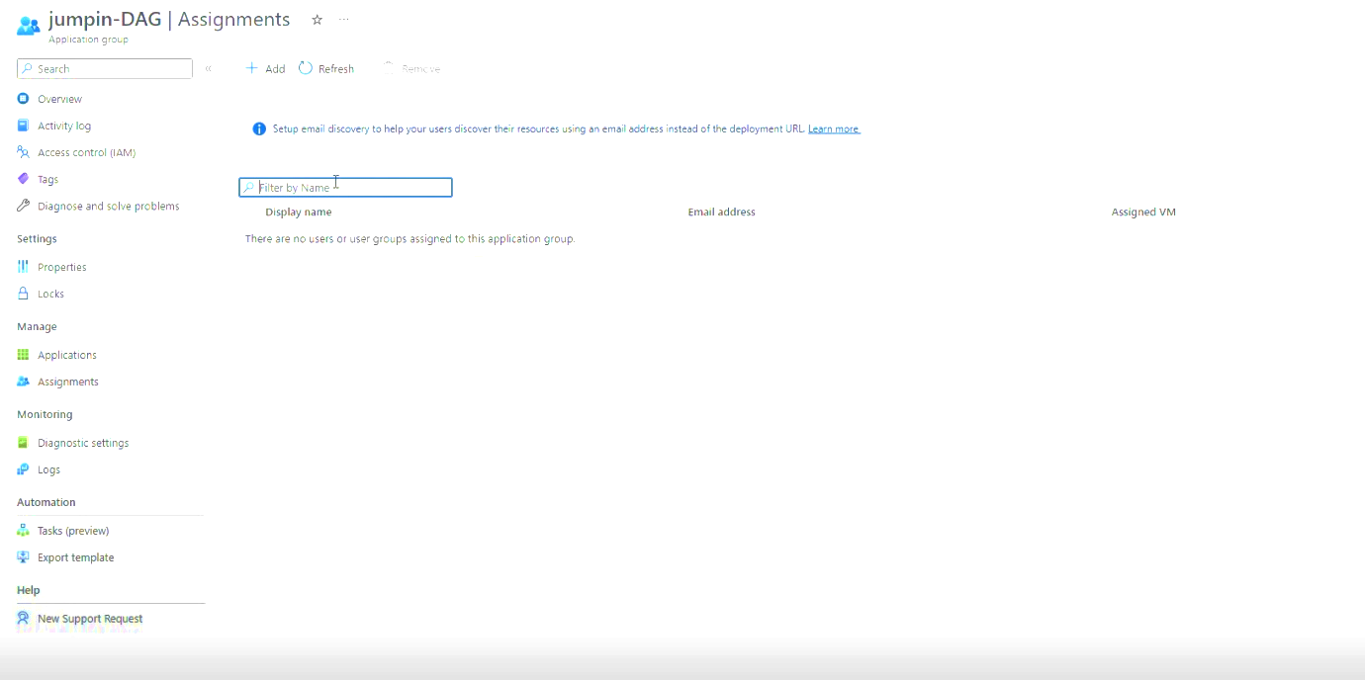Click to Add member to Access AVD.
* 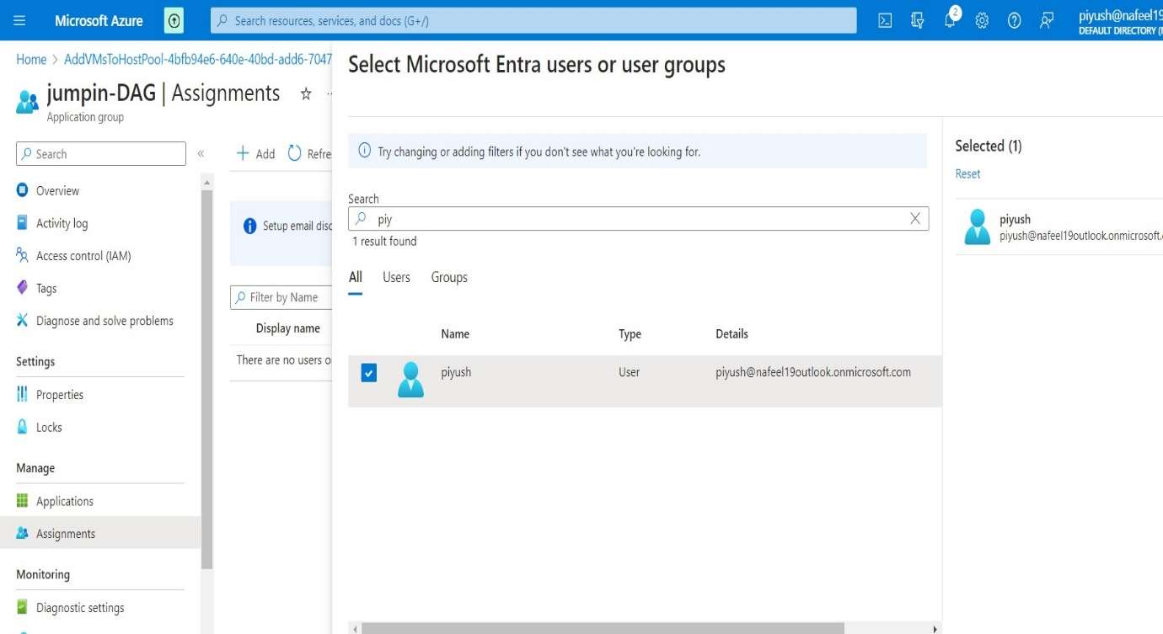Select Users as per requirements

1. **Add Role Assignment and Add members:**

* To Access AVD, required some Additional Access Role.
* In the Azure portal, select 'Resource groups' which we Created AVDscale.
* 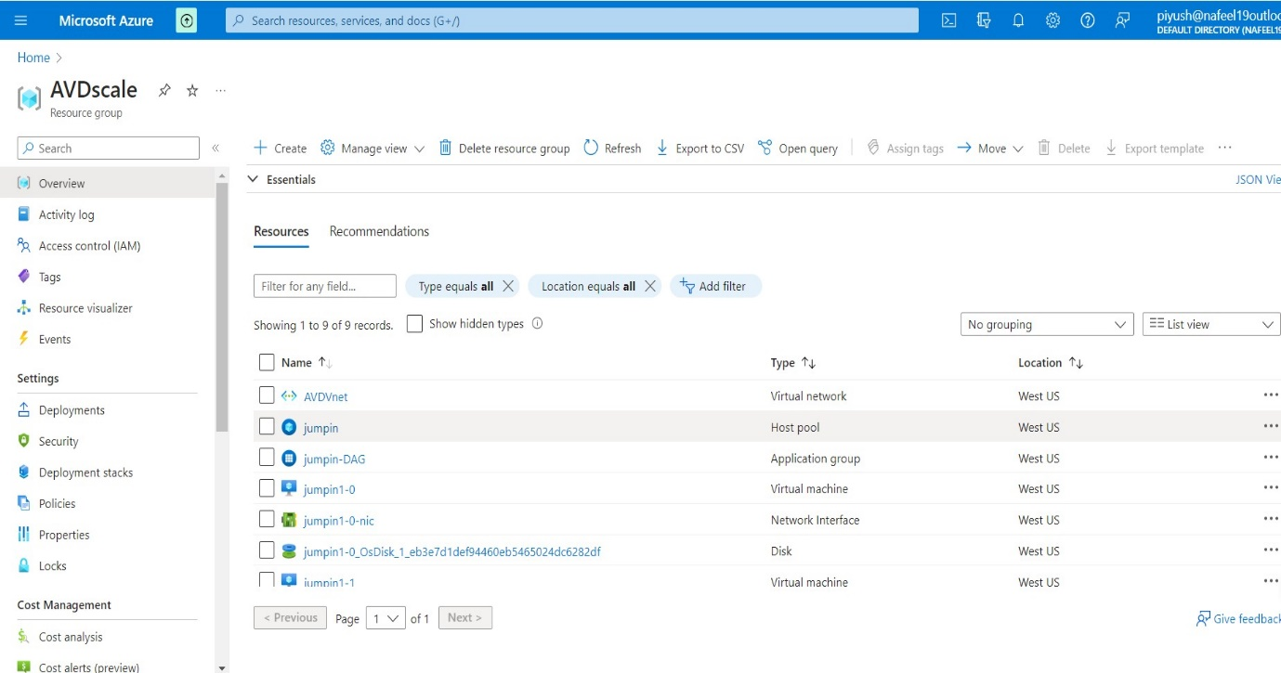Click on Access Control (IAM)

**←**

* 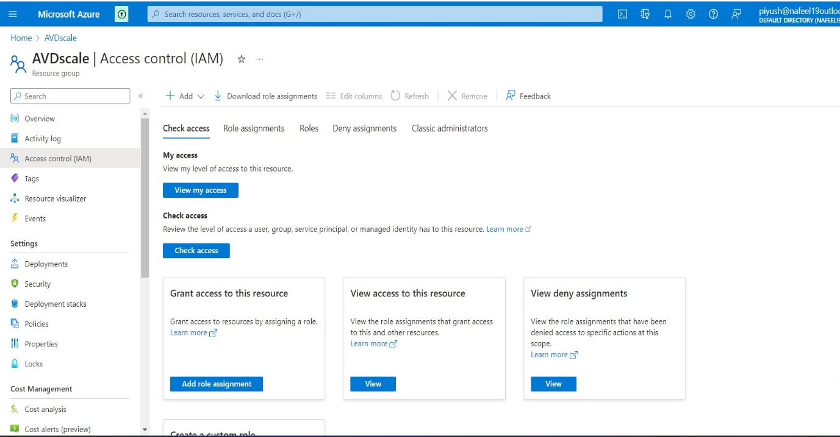Click to Add.

**↑**

* Click on Search → Virtual Machine User login →Select and Assign
* 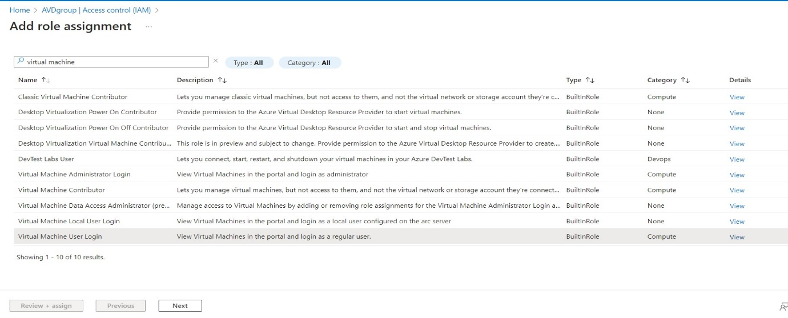Click to Next
* Click to Select members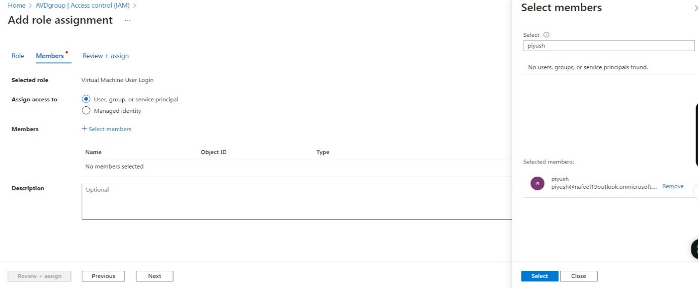

**← click on select**

* 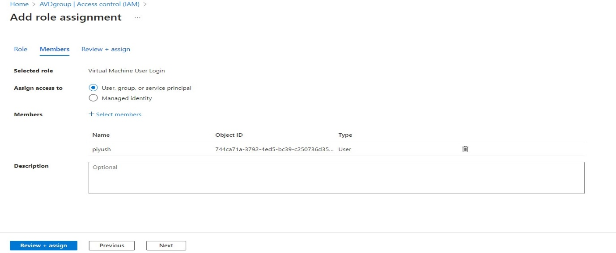Click to Assign
* Again, Same Step
* Click on Search → Virtual Machine Administrator Login → Select and Assign
* 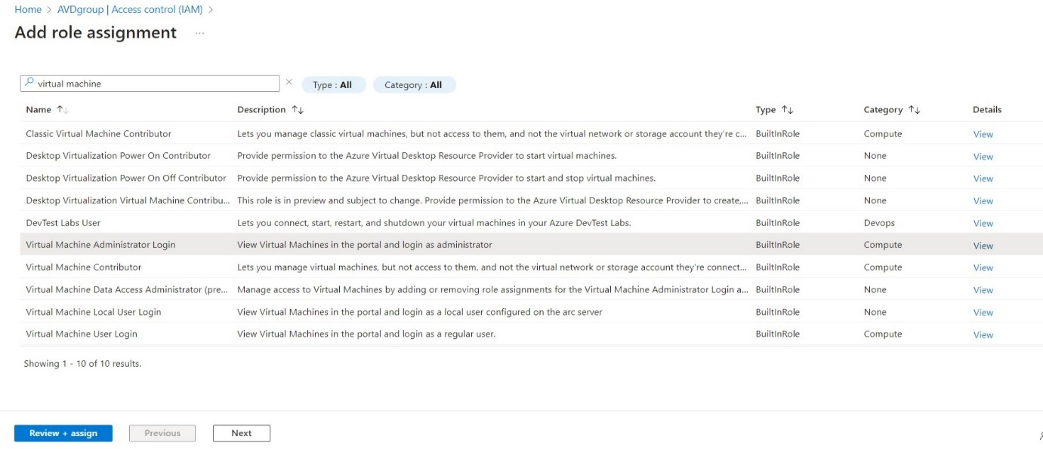Click to Next
* 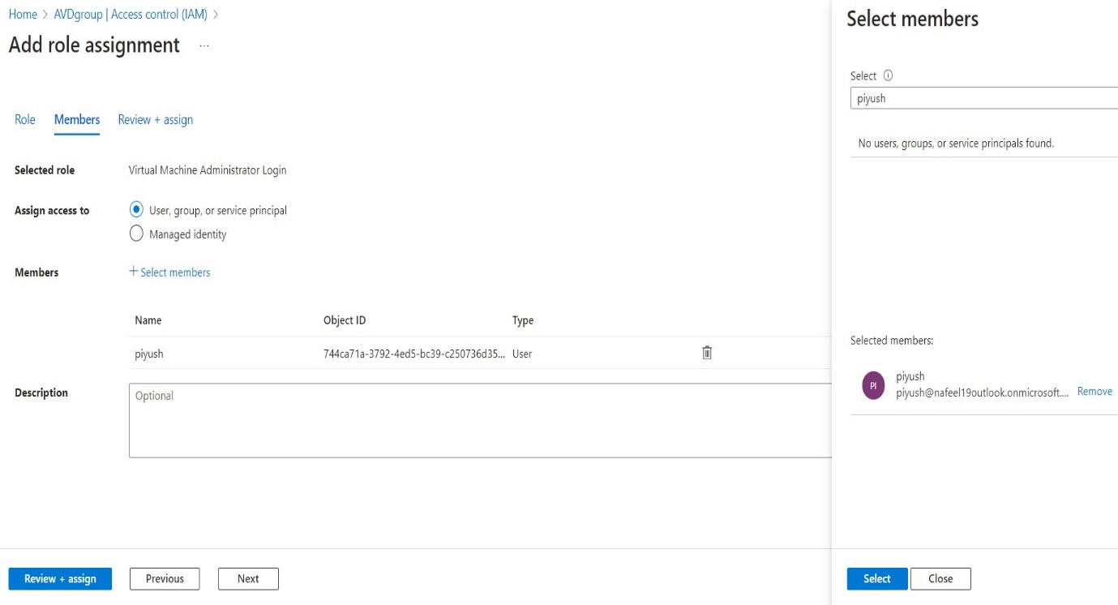Click to Select members And Assign

**← click on select**

1. ***Add virtual desktop workspaces:***

* In Azure Portal, search for Azure Virtual Desktop.
* Click on Create a host pool.
* In Mange → Click on Workspace.
* 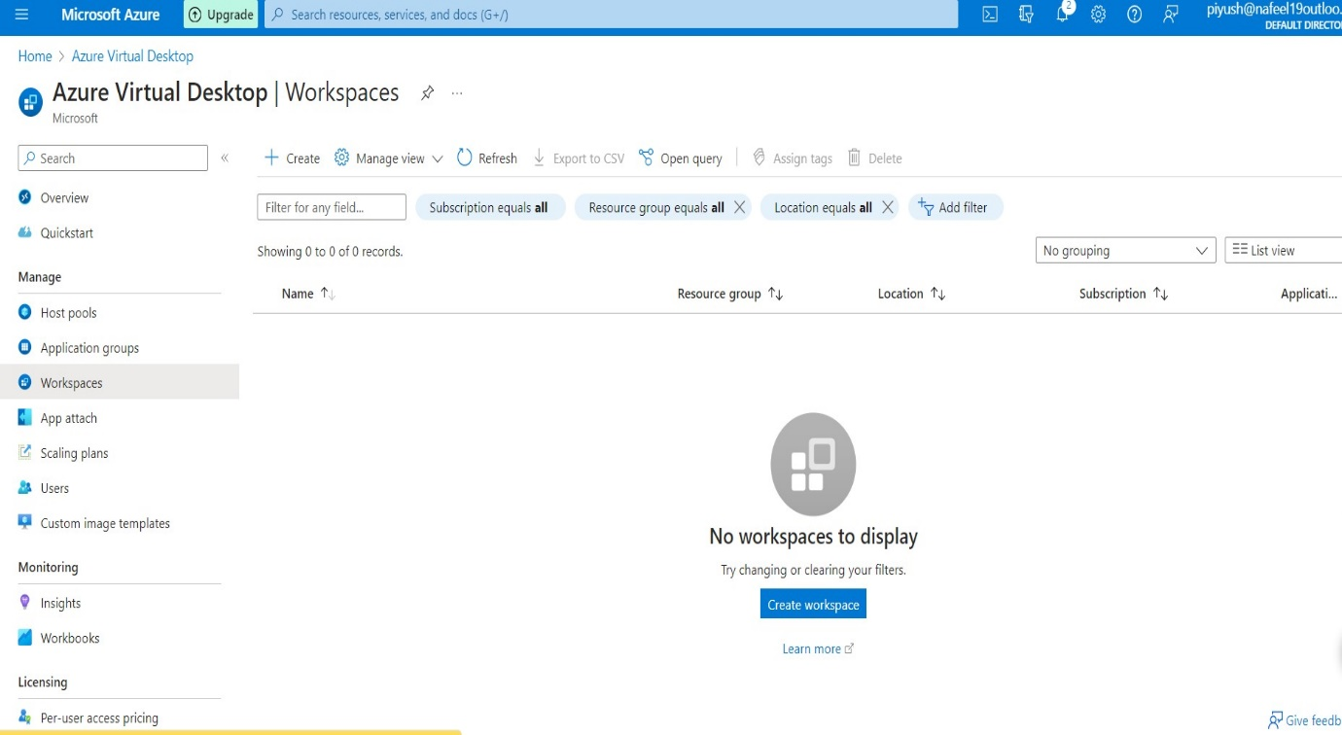Click to Create Workspace.

**↑**

**Click to Create**

* + Add existing created Resource group AVDscale.
  + 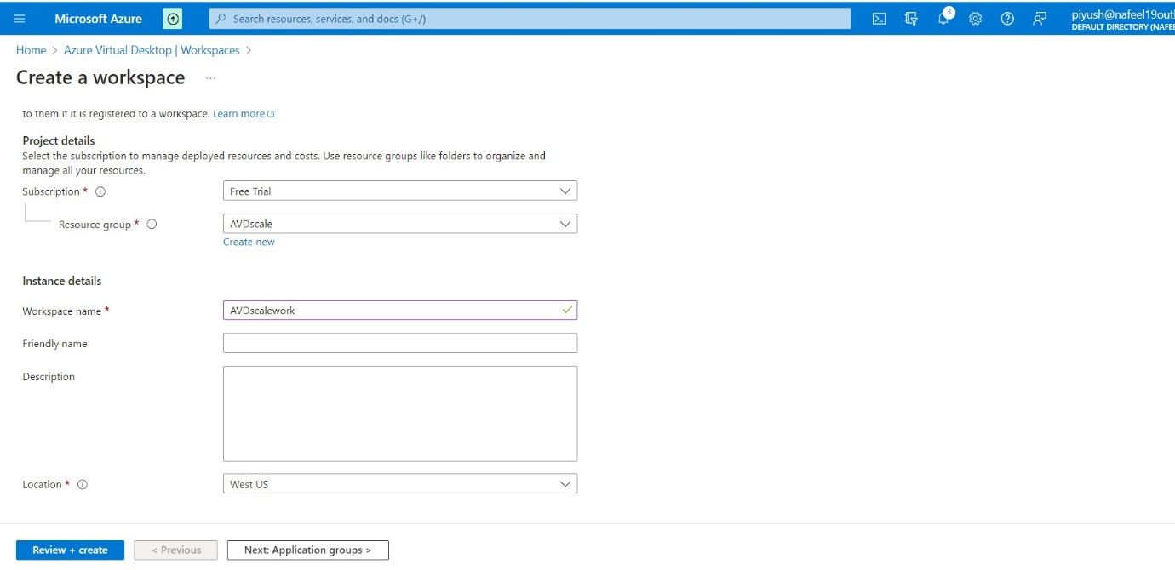Add a Workspace name and location West US, keep same location for all the process in AVD.

* + 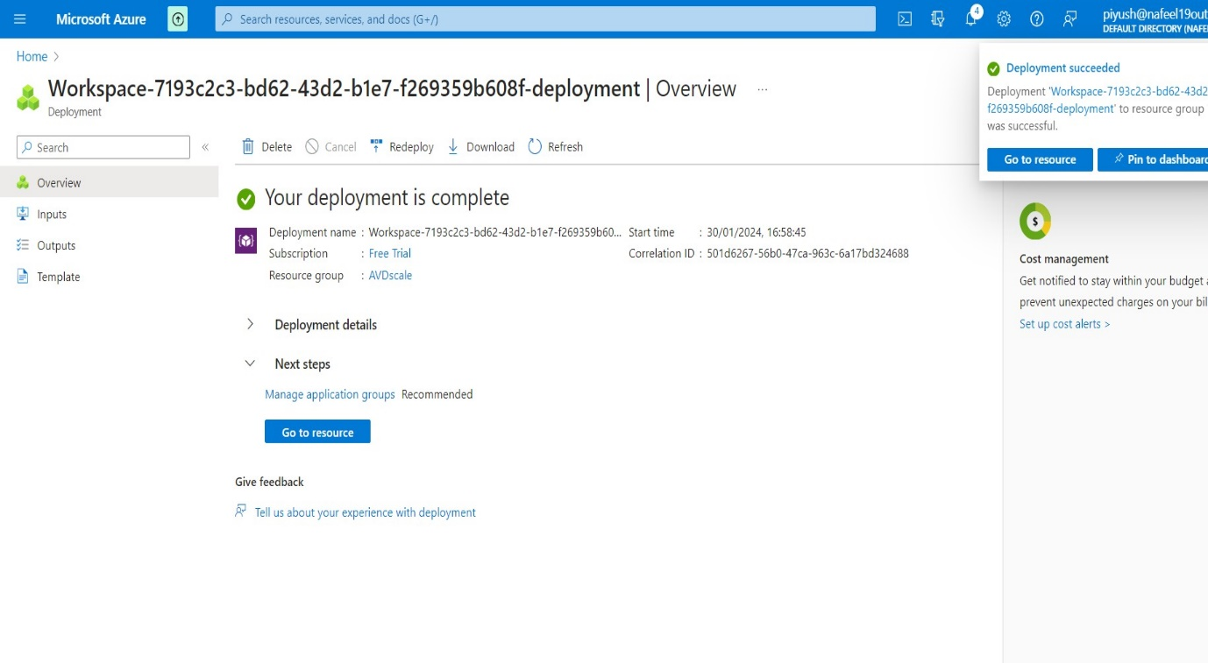Click to Create Workspace.
  + In Manage → Click on Application group.
  + 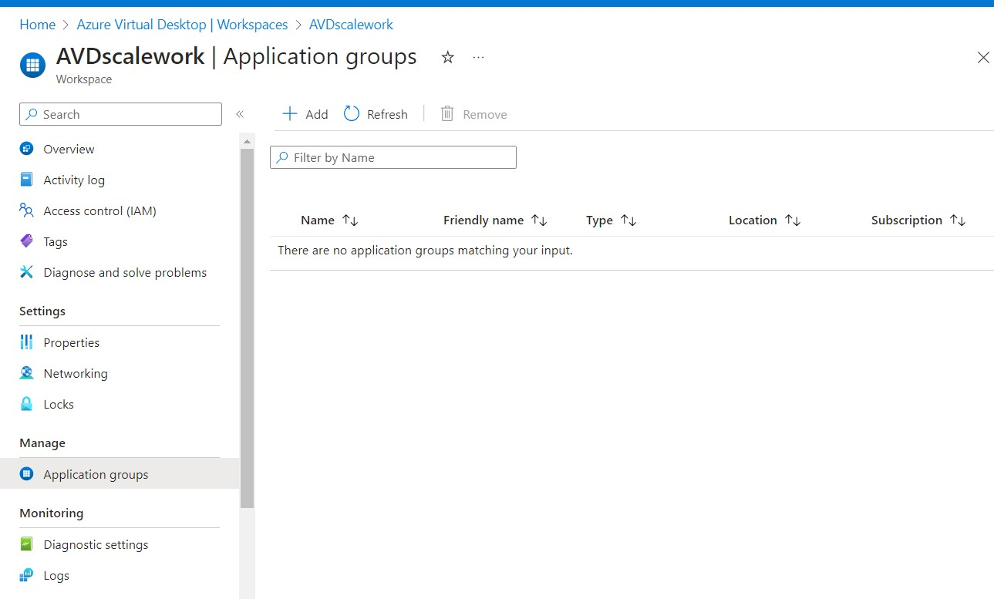Click on Add

**←**

**↑**

**Click to Add**

* + 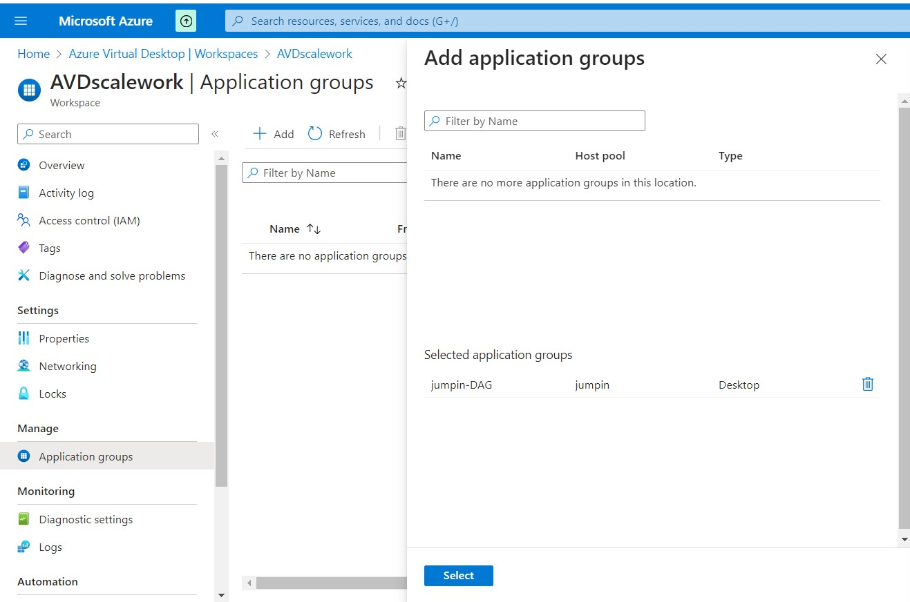Select that Application groups, which we Created by host pool.

**←**

**←**

1. ***Configure Virtual Desktop host pools:***

* In Azure Portal, search for Azure Virtual Desktop.
* Click on Host pool we Created jumpin
* In settings → Click RDP properties.

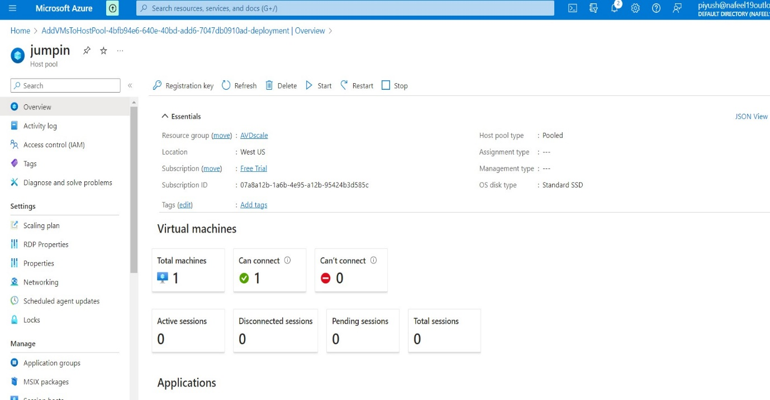

**←**

* Click on Advanced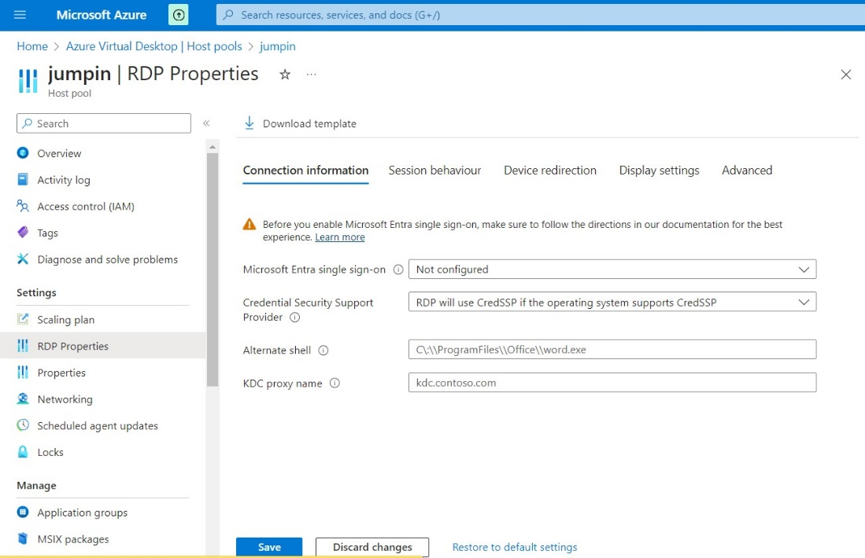

**↓Click on Advanced**

**↓Click on Advanced**

* In Advanced type this → **;targetisaadjoined:i:1**
* 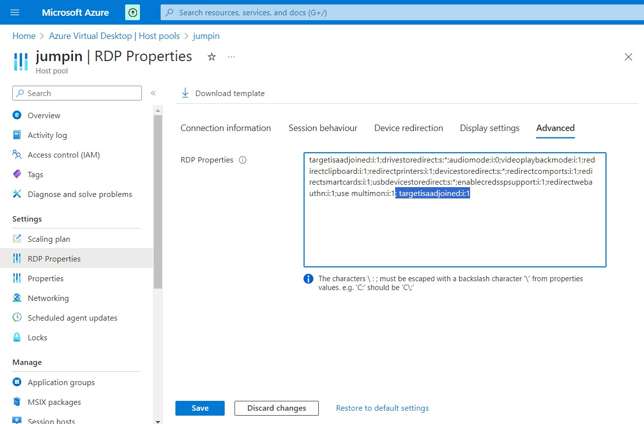Click to Save

1. ***Log in to the Azure Virtual Desktop:***
   * After configuring your AVD host pool, you're ready to login to the Azure Virtual Desktop.
   * You can use the following link:

<https://rdweb.wvd.microsoft.com/arm/webclient/index.html>

* Copy this link and past in new tab
* 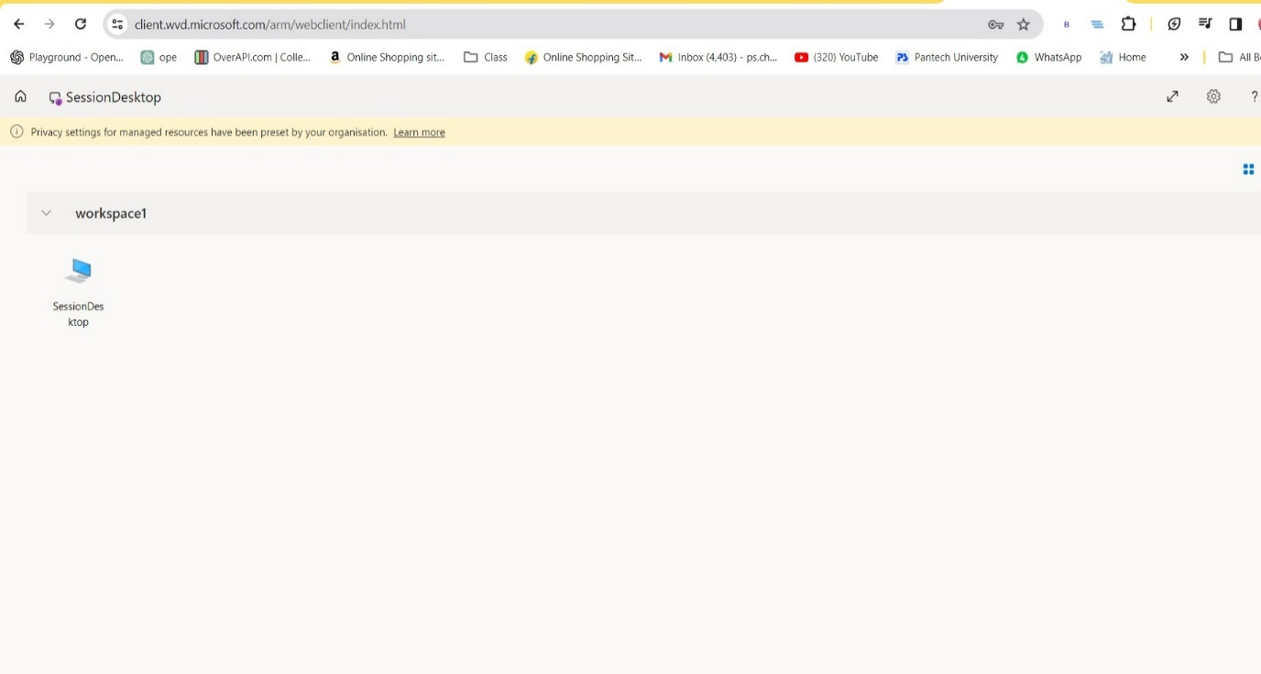Click on Session

**← click on SessionDesktop**

* Enter Username As per Selected AD User and Assign Role
* 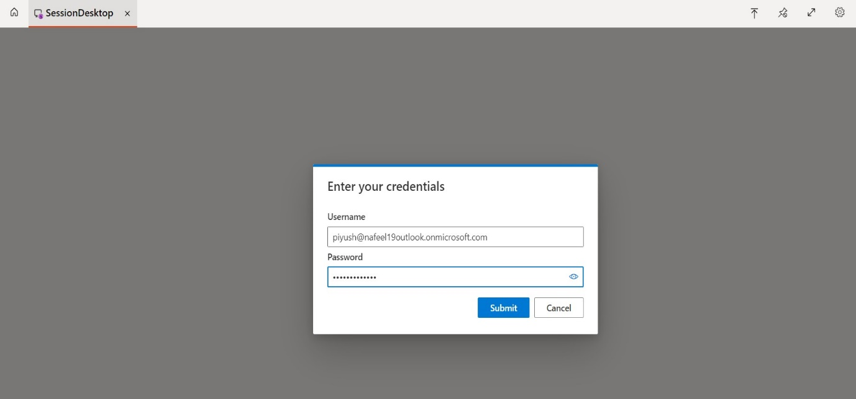Enter Password and Click to Submit.
* 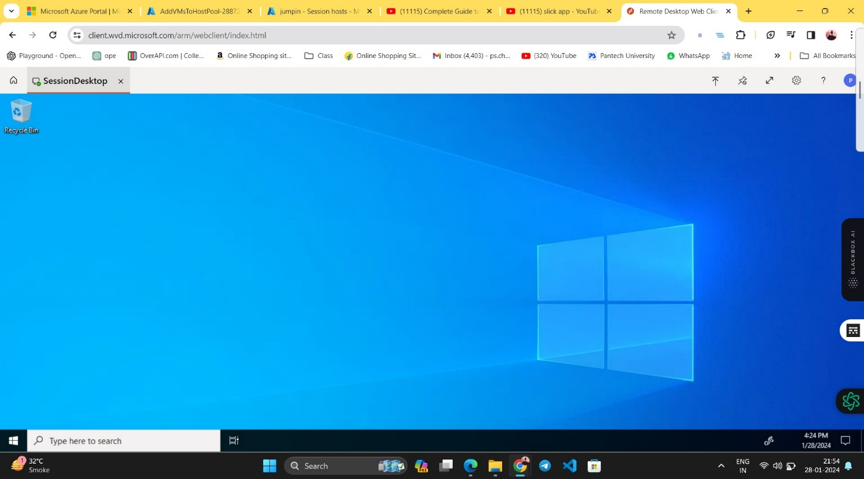 Now AVD Session Desktop Setup is Ready

1. ***To Add Session host manually to Host pool:***

* Open Created, Host pool
* We can see, we have Total machine 1.
* 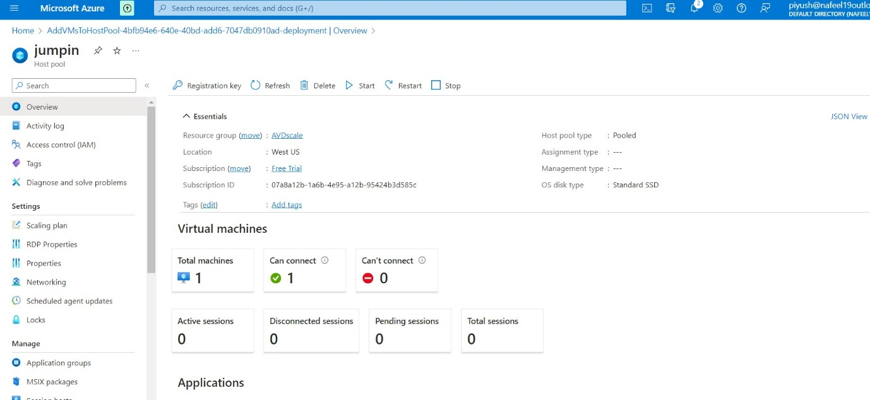So, to Add one more session host manually to host pool we need VM

**↑**

**To Add more machine as a Manually we need to Create VM**

* In the Azure portal, select Virtual Machine
* 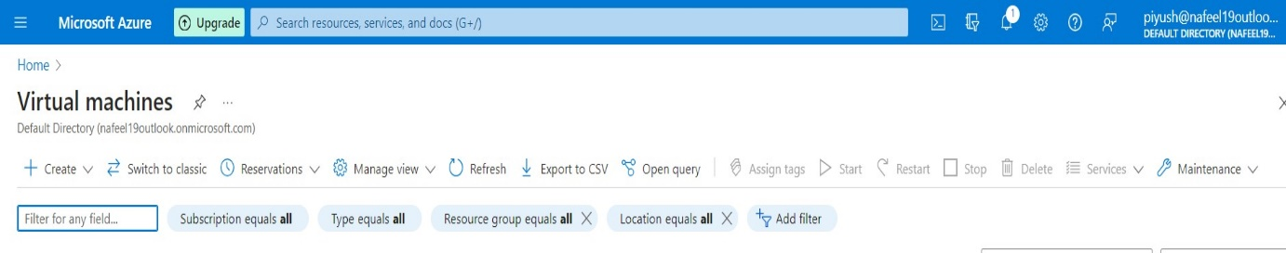Click to Create VM
  + In the Virtual Machines tab,
  + Add existing created Resource group AVDScale.
  + Add VM name as per requirement
  + Existing created Region west US
  + Image As per requirement
  + 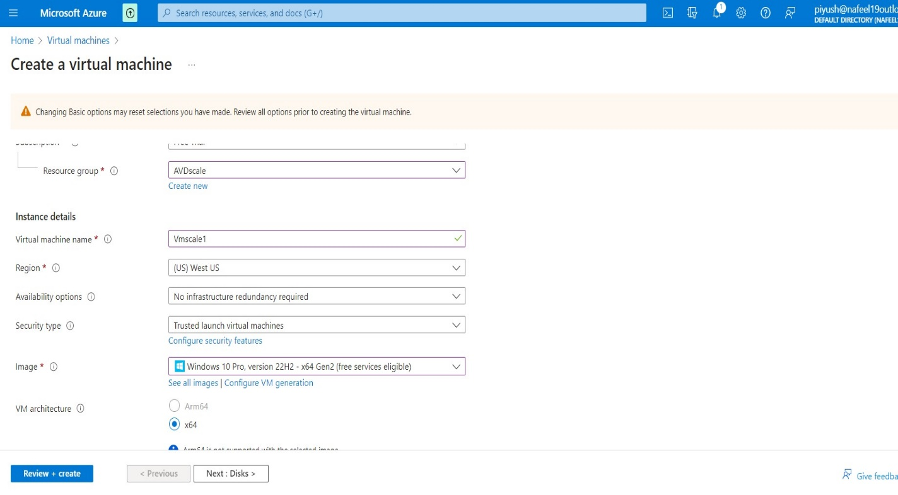Select size as per requirement
  + 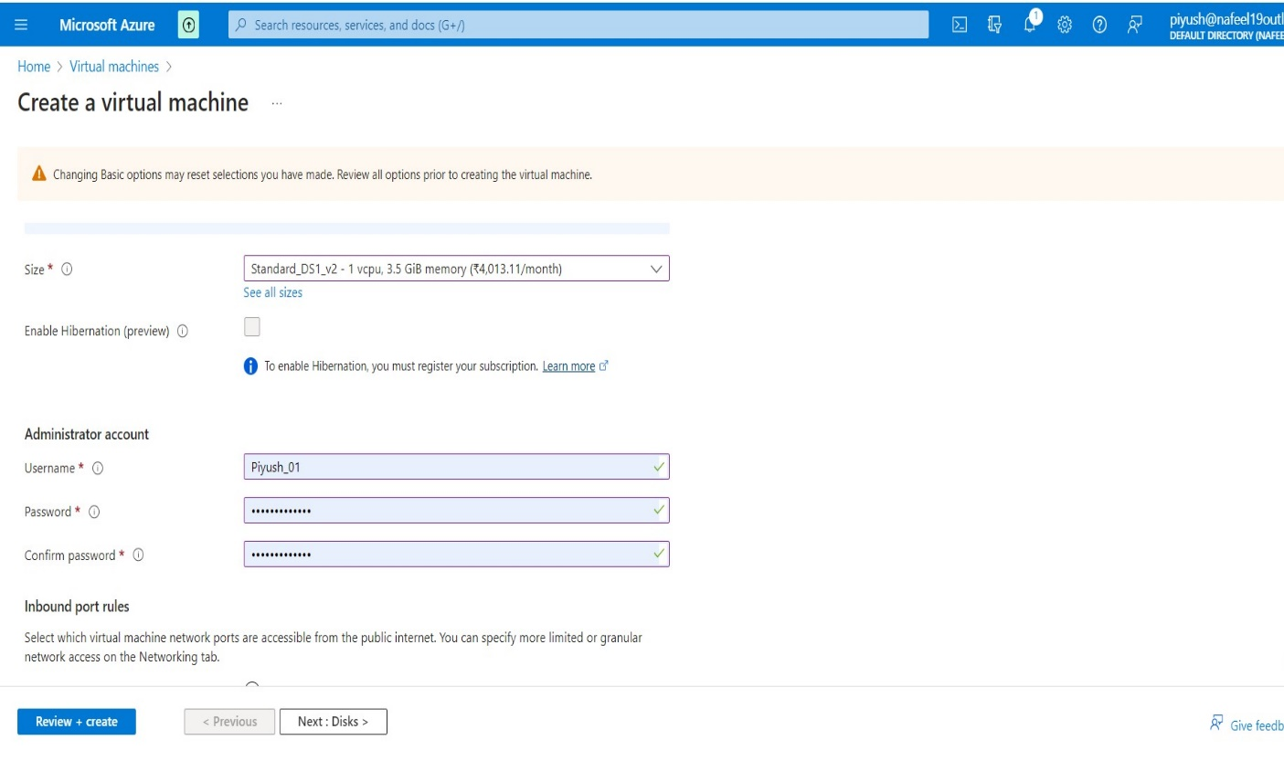As a last step in this tab, put user name and Password administrator account so you can access the VM
* Os disk as per requirement

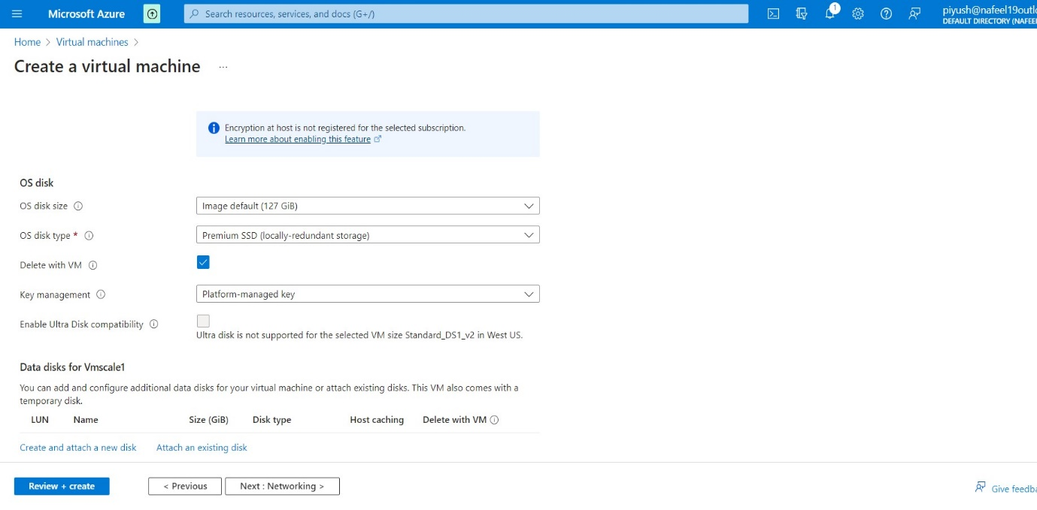

* 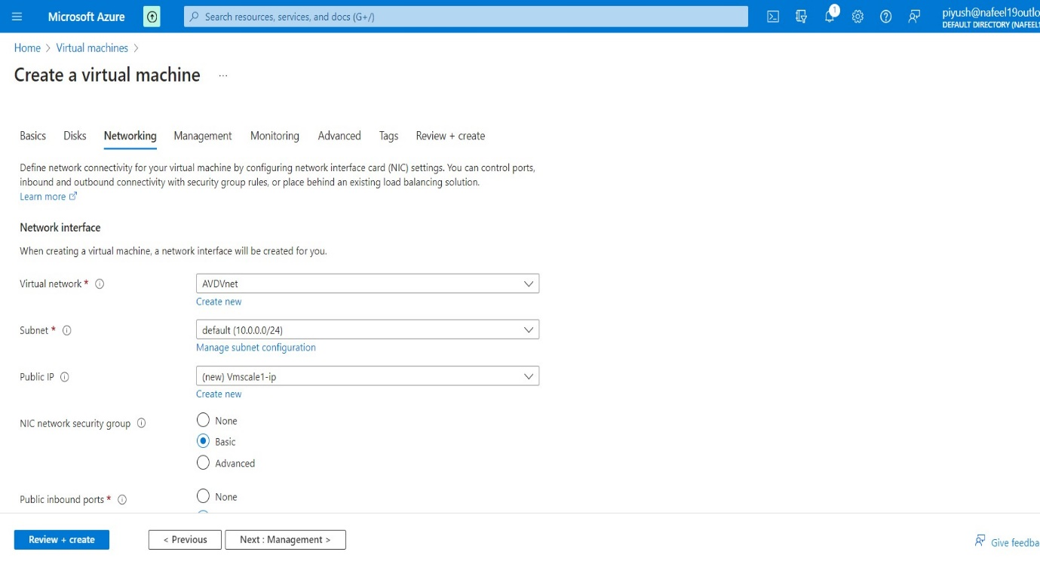Network interface keep Default
* 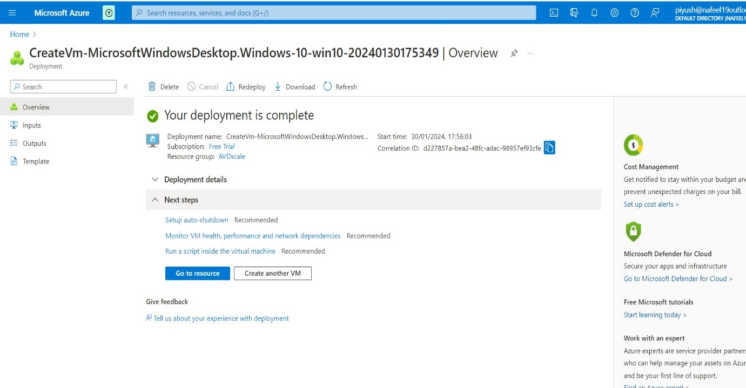Click to Create VM
* 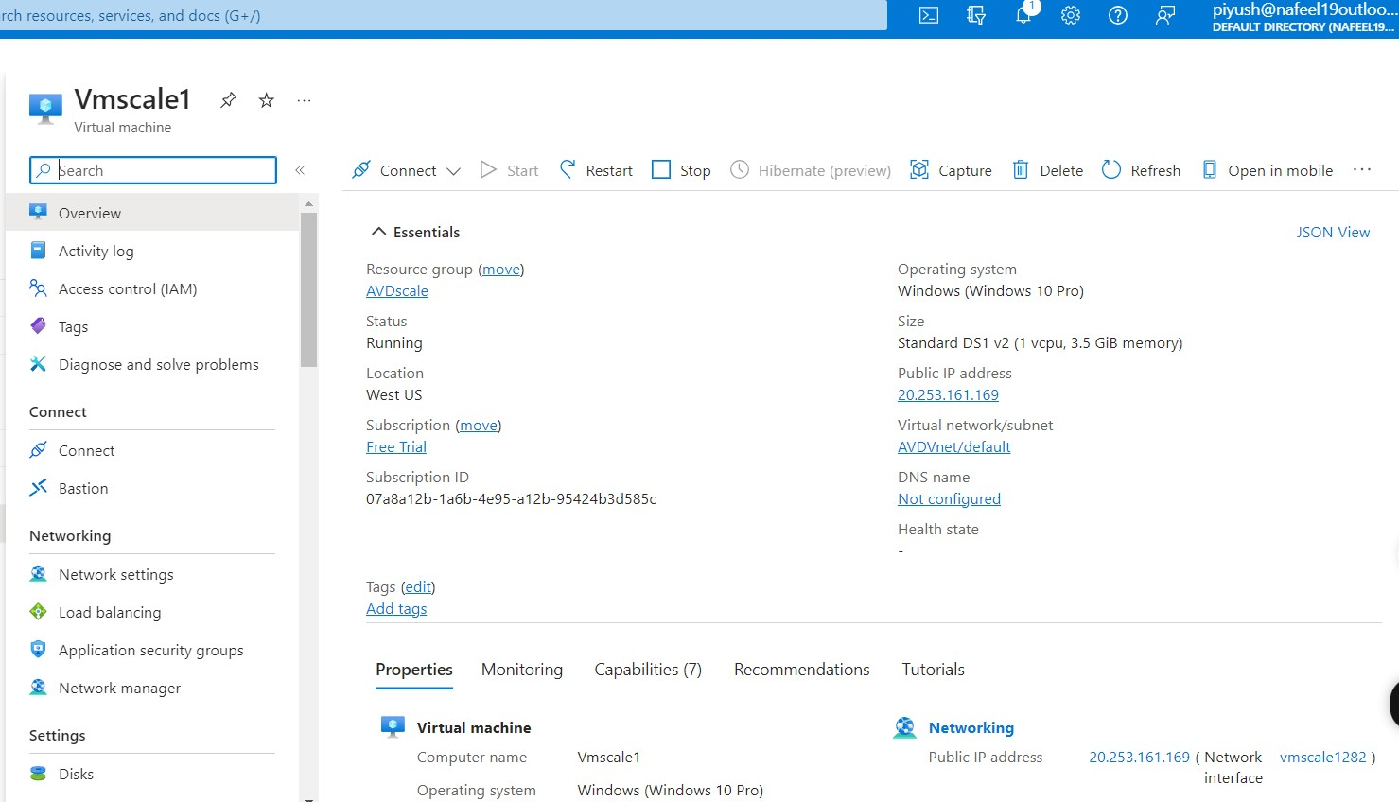Click to Connect VM

**↑**

* 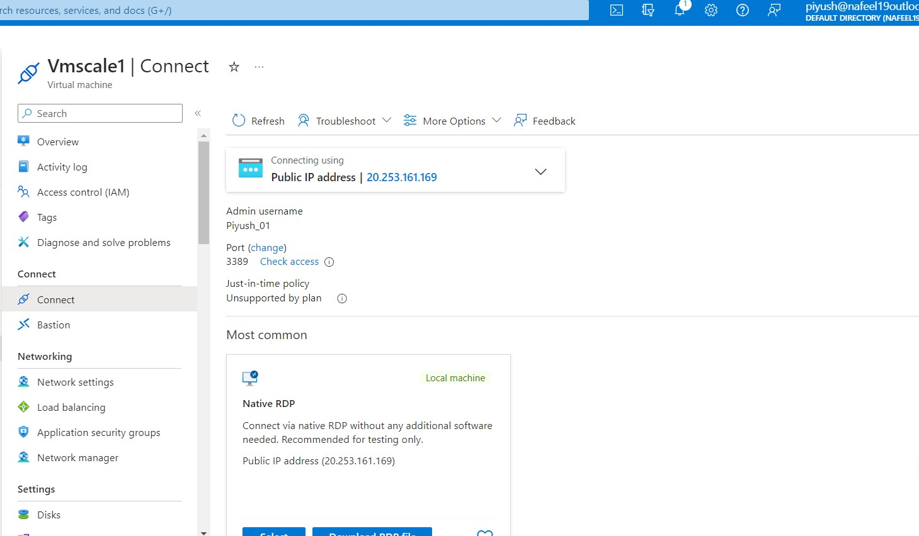Copy that public Ip address
* Click on start menu and Search Remote Desktop connection
* Past the ip address

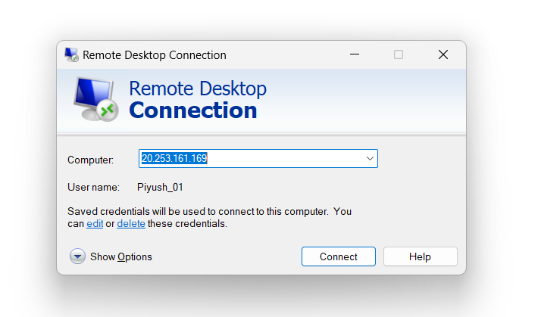

* VM is ready
* To Connect our VM to AVD we need to install infraAgent
* Select window
* And type \\jumpin1-1\c$
* 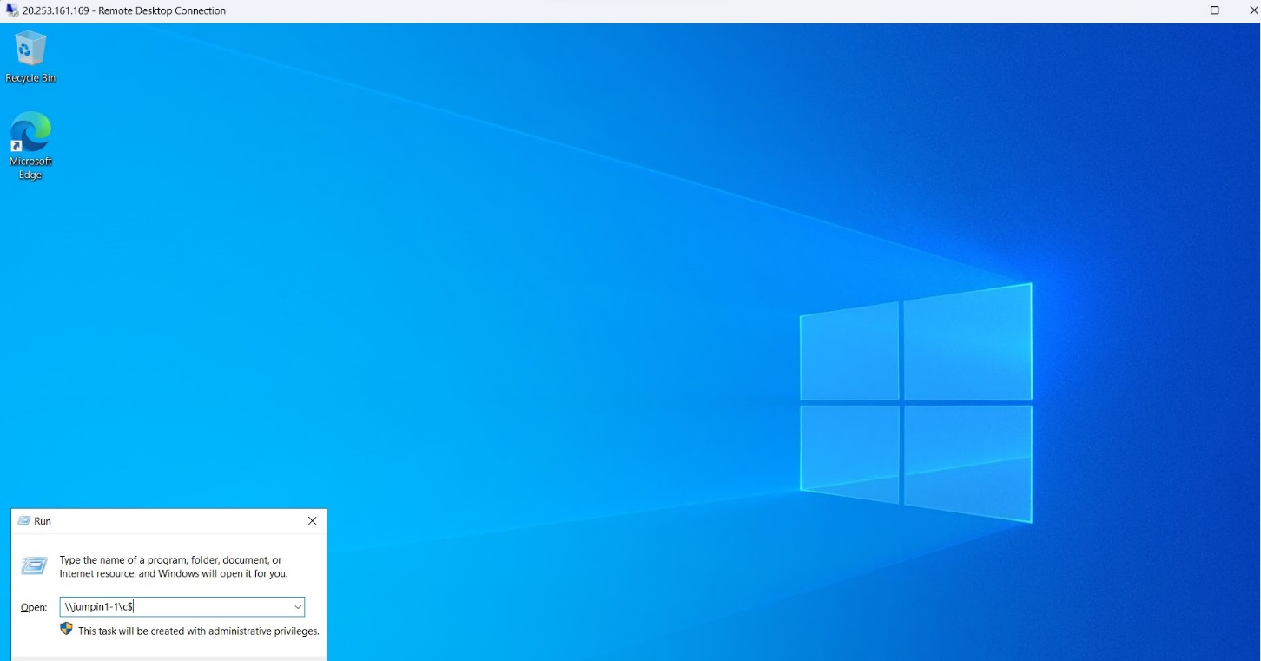Jumpin1-1 is Host pool Machine name which we created
* 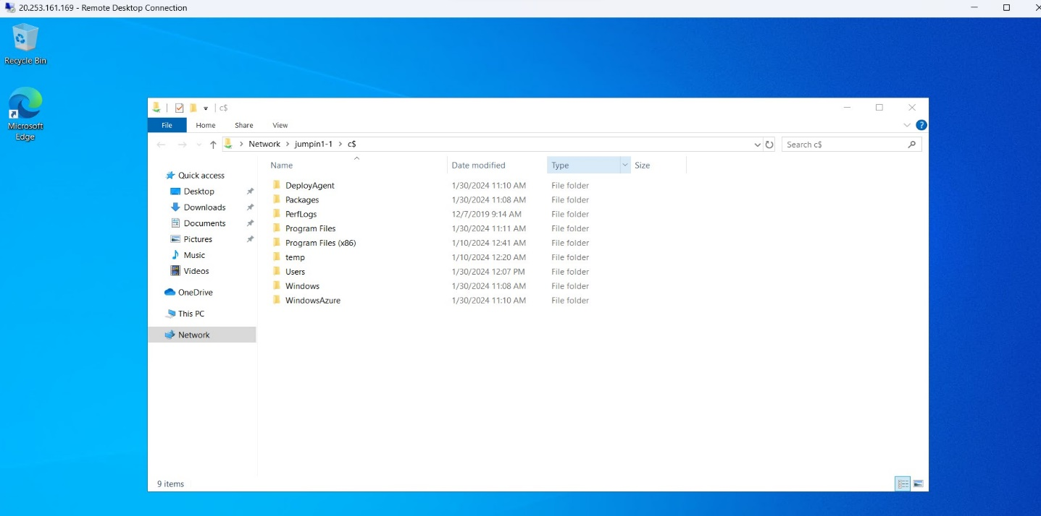Click on Deploy Agent
* 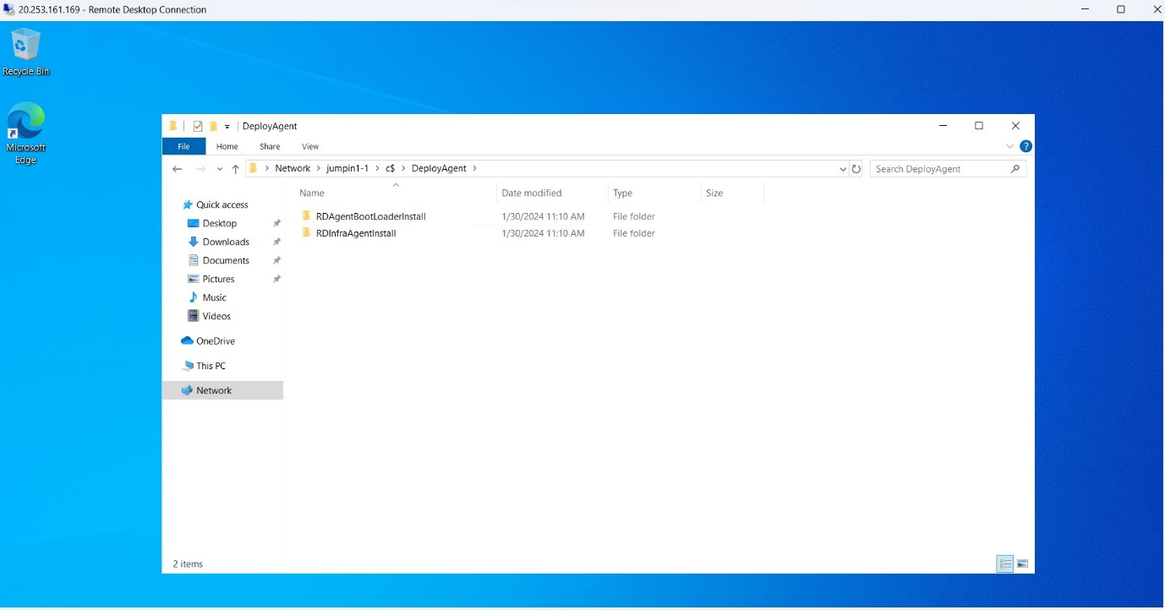Select that two file and copy into this Pc, C drive.
* 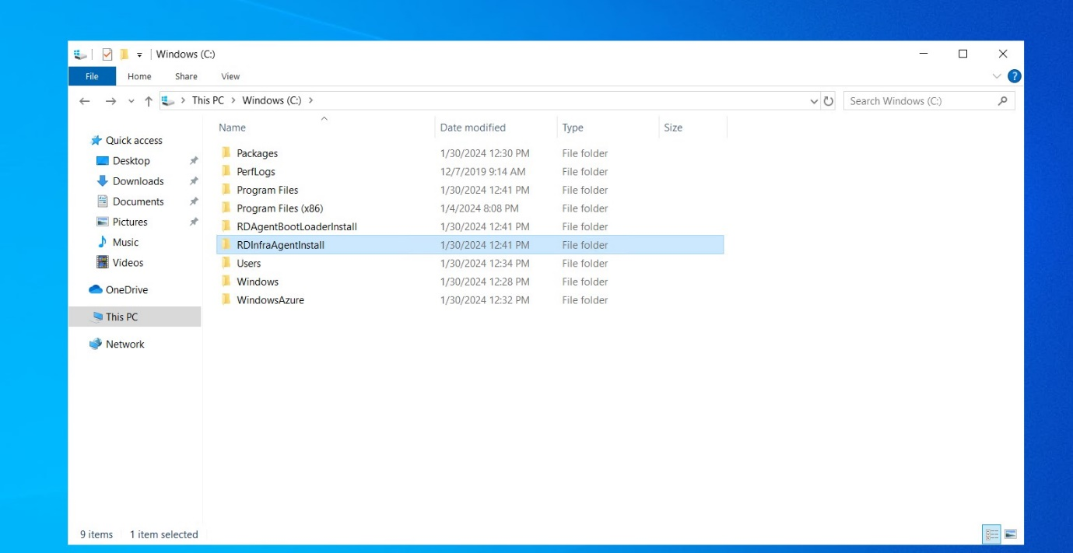After that click to RDAgentBootLoaderInstall
* 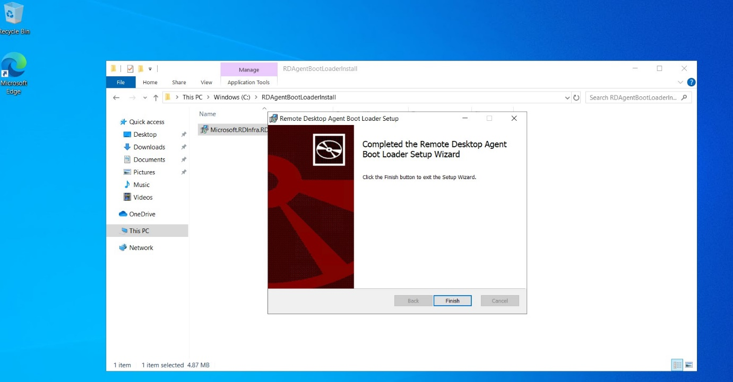Click to install
* After that click to RDInfraAgentinstall

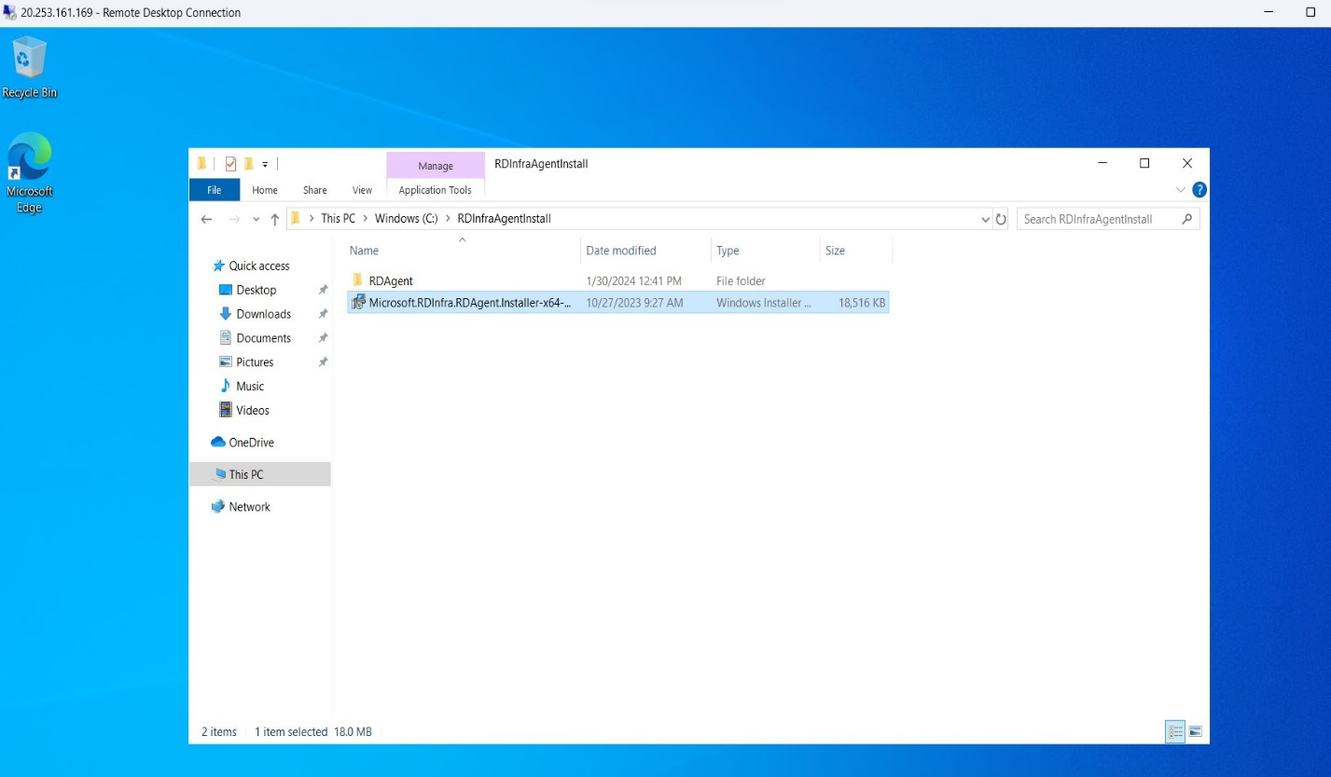

* To Install RDInfraAgentinstall we required host pool Registration Key to Connect VM to AVD
* Go to Azure portal, Search AVD Host pool we create

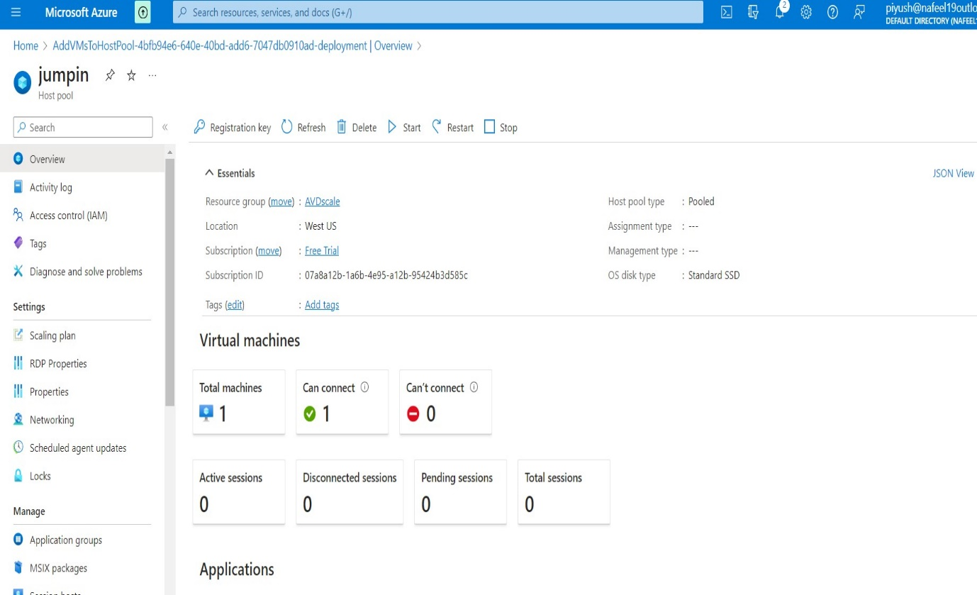

**↑**

**Click to Registration key**

* Copy that Registration Key

eyJhbGciOiJSUzI1NiIsImtpZCI6IkY5NTVDQTVDNTAyMDJGMEY3NTc0RUE2M0Q3NkM4NUNFNjZBNzI3ODkiLCJ0eXAiOiJKV1QifQ..Ip2tSGAd_LwaiCPhX6sOy_BdeEpkMbxYDMvsF1_jgb44hoatQ_nyFv_8lhVJ4BCUCbOg44zgQ4_CjDVec6-H5NmIcXIUUiFuI7VTe1SYFMDa7njsf2iqK3r9eq8De3WeOH0DQqY7x-UUxSb793IO-39Zurl3nJ0KZ1gV5Q0gcVtLthkL0pWJ7vxq2y5GPuh_uAx9Vs2SWoNOFVNo6f7t9kL1HPnPJgdxrMtIU_iKbZ4u_w7STxfRB-CPnpHhMv6whPOFAbYd5o-YhAmfJm9V_sjQxIfLru8yOdiQc9p0TzxWyHKDOEFZAbOzC_zpDV3q5Qf3Lzh2xfmmMGUMNcdtNQ

* 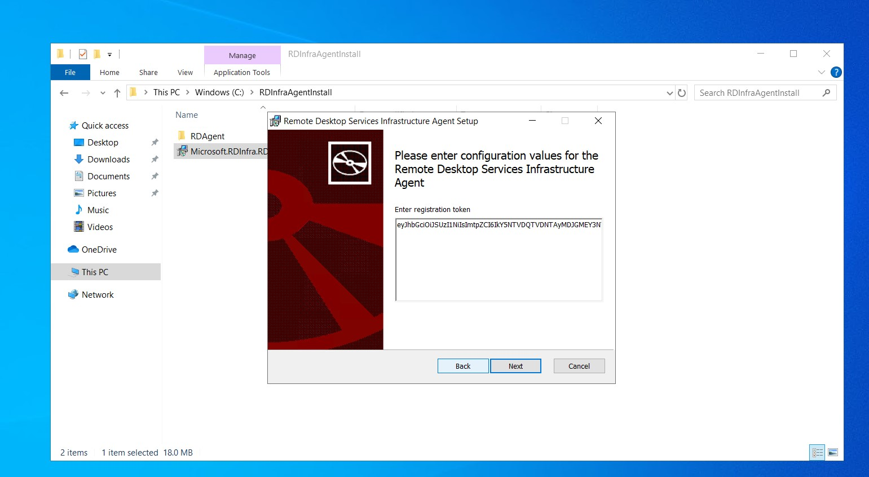Past that Registration Key

**←Past that Registration key**

* 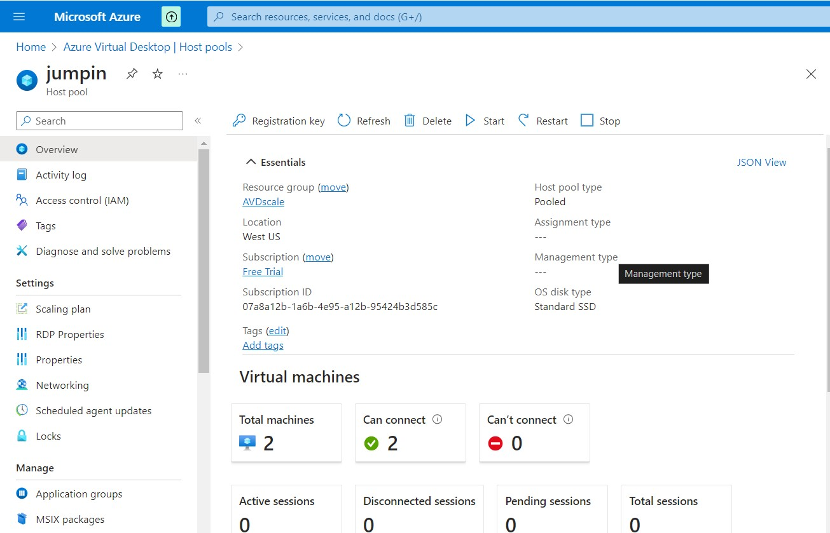we can see two Machines are Available.
* 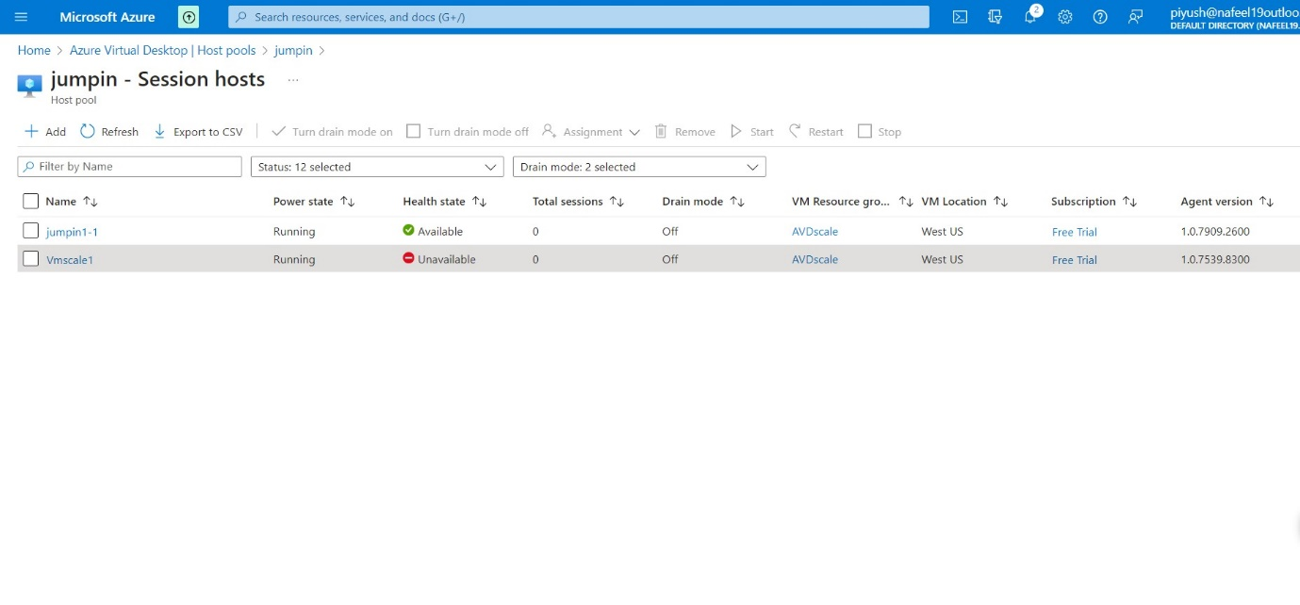Now we can see Add one more session host manually to host pool